

3/13/2016

LEAD

Cairo University

Faculty of Engineering

Computer Department

**LEAD Project Time Plan**

**Background**

The LEAD website (Learn, Explore, Achieve, Develop) brings together many of Faculty of Engineering –Cairo University’s Student activities in one easily accessible place. So instead of browsing through each activity’s site or just following their Facebook’s page – which is not efficient because most of the time links disappear in the numerous news in the homepage – students could just open our website and find all the news he/she wants about each student activity in one place.

For example users can choose which category of events, workshops…etc. to be notified about when it happens which allows them to get more involved in what they really care about.

So our main goal is to help students get the most benefit from student activities and help them make their own mark in life.

**Scope and Objectives**

The following items are to be delivered to the client:

* Profile: each user has profile contains his data and interests.
* Home: which contains admins posts about events and workshops.
* Search: helps user to find his favorite events.
* Comments: which allow users to communicate with each other.
* Notification: by sending an email to each user to notify him with new events.

**Timeframe**

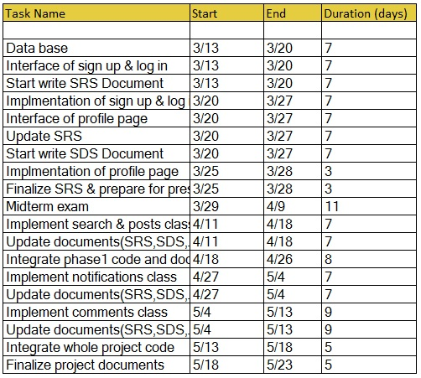

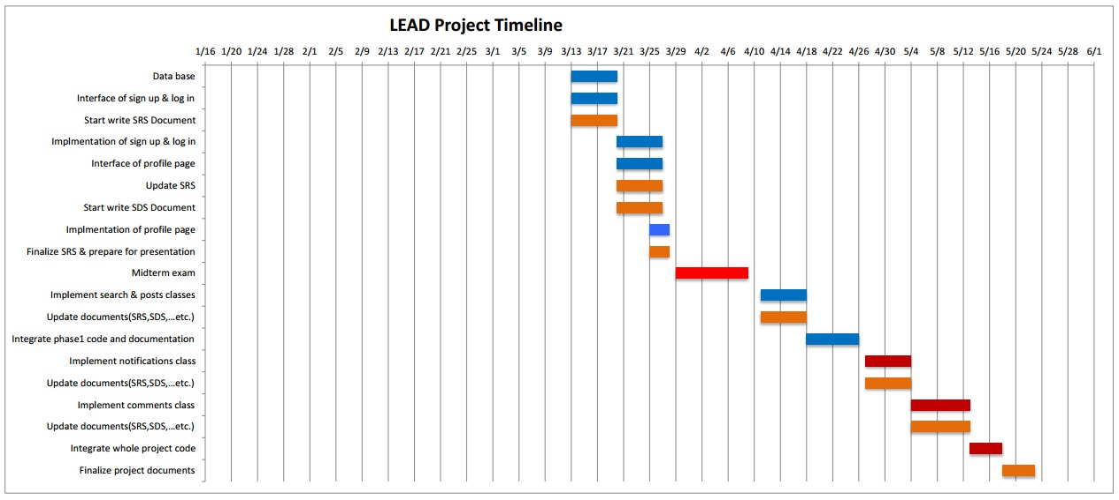

Phase2

Midterm

Documents

Phase 1

**Key Stakeholders**

|  |  |  |  |
| --- | --- | --- | --- |
|  | Name | E-mail |  |
| Clients | Dr.Bassem Ibrahim | [basem@eng.cu.edu.eg](mailto:basem@eng.cu.edu.eg) |  |
| Eng.Lydia Waheed | [eng.lydiawahid@hotmail.com](mailto:eng.lydiawahid@hotmail.com) |  |
| May Mohamed | [mai_awadalla@yahoo.com](mailto:mai_awadalla@yahoo.com) | IEEE member |
| Mennah Lotfy | [mennalotfy33@gmail.com](mailto:mennalotfy33@gmail.com) | STP member |
| Rania Alaa | [Rania.alaaa@yahoo.com](mailto:Rania.alaaa@yahoo.com) | Meshwar member |
| Team Members | Tasneem Saif | [tsasaif@hotmail.com](mailto:tsasaif@hotmail.com) |  |
| Maryam Mohamed | [maryam.m.abdelmoneam@gmail.com](mailto:maryam.m.abdelmoneam@gmail.com) |  |
| Mennah Rabie | [eng.m.rabie7@hotmail.com](mailto:eng.m.rabie7@hotmail.com) |  |
| Yasmeen Hesham | [yasmeenhesham09@gmail.com](mailto:yasmeenhesham09@gmail.com) |  |

**Monitoring and Evaluation**

| **Monitoring** | | | | | | **Evaluation** | | |
| --- | --- | --- | --- | --- | --- | --- | --- | --- |
| **Broad Evaluation Questions** | **What do we want to know? (Monitoring Question)** | **How will we know it?**  **(Indicator)** | **Where will the data come from?**  **(Data Source)** | **Who will capture the data?**  **(Responsibility)** | **When will data be captured?**  **(Timeframe)** | **Who will be involved?** | **How will it be reported?** | **When will the evaluation occur?**  **(Timeframe)** |
| **Was the project delivered as planned?** | How many Features were delivered? | Number of delivered features | Available features on the website | All the Team Members | After the project completion | All the Team Members | Meetings | After finishing the project |
|  | Was each Feature delivered in time? | Time taken to make each feature | Timeline | Team Leader | According to the Timeline | All the Team Members | Meetings | After each delivered feature |
|  | Are the finished features as planned? | The planned features | Project plan | All the Team Members | After finishing each feature | All the Team Members | Meetings | After each delivered feature |
|  | Are the users interested in the available features? | Users feedback | Survey | All the Team Members | After each delivered feature | All the Team Members | Meetings | After each delivered feature |
|  | Does each team member finish his task in time? | The deadline of each task | Timeline | Team Leader | After finishing each task | All the Team Members | Meetings | After each delivered feature |
|  | Does the website help the students getting in touch with the student activities? | Users feedback | Survey | All the Team Members | After making the first prototype | All the Team Members | Meetings | After finishing the project |
|  | Is the website user friendly? | Users feedback | Survey | All the Team Members | After finishing each prototype | All the Team Members | Meetings | After finishing the project |